**Smart Soldier Strap**

**Aim:**

In this paper we present an Internet of Things based Soldier Health Status Detection and Location Tracking System using Internet of Things for the safety purpose of the soldier. The soldier is the critical unit of the nation and their life is valuable. Lot of soldiers are facing many problems such as communication with the control room and no proper medical help at a proper time which leads to the death of the soldier. To minimize such cases, we have proposed a continuous alert system to track location and monitor the health of the soldier. The proposed system is very useful in detecting location of the soldier in real time using GPS and communicating the health status parameter continuously using GSM module embedded in microcontroller. The tiny sensors can be fixed to the Soldier body or dress of the soldier to detect body parameter and transmit the information to the control room and other solider when there is a low body rate or when it falls than the defined threshold value. The soldier can send an alert message to the guardian and control room for the help in the panic situation using an application. The control room/guardian also uses android application to request the location of the solider automatically in the panic situation. The soldier can also request for the nearest hospital information in the emergency.

**Hardware & Software Requirements:**

1. Raspberry Pi
2. SIM 800 GSM Module
3. Neo6mv2 GPS Module
4. Heartbeat Sensor
5. Temperature Sensor
6. LCD Display
7. Buzzer
8. Crystal Oscillator
9. Resistors
10. Capacitors
11. Transistors
12. Push Buttons

**Project Flow:**

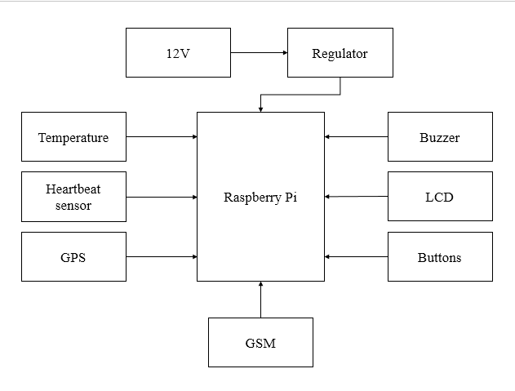

**Proposed System:**

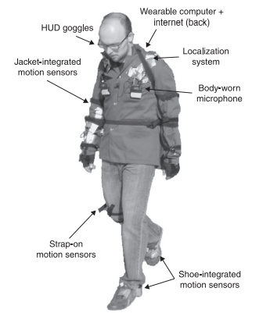

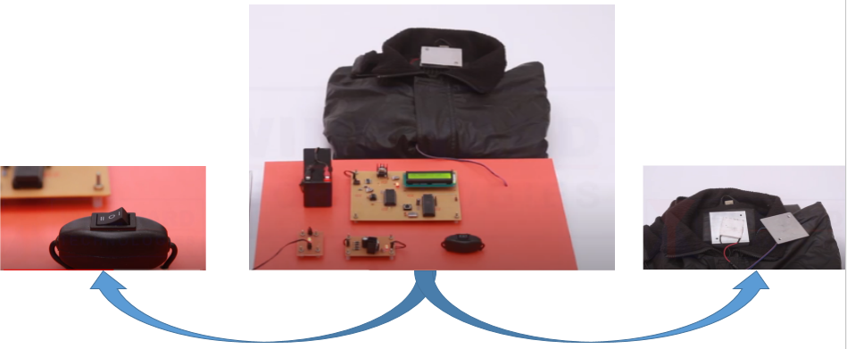

**Stake Holders:**

The main stake holders would the defense person itself as they are the one who serves the nation and moreover they are the one who will be benefitted from it. As their current status can be known from anywhere when in mission.

The next main stake holders are those who are handling these organizations i.e. the Department of Defenses since each and every country are on their way to enlarge their defenses and always work on advanced defenses So they are the next main stake holders.

Finally comes the defenses who work on the advancement of the prototype and use these om order to simplify them and also provide additional features if possible.